**COVID-19 Treatments Social Media – English and Spanish**

**California Department of Public Health**

--------------------------------------------------------------------

**Please use and share these animated social media GIFs - we would love to see you getting the word out about COVID treatments on your social media ahead of the holiday surges!**

**Links to the downloadable mp4 files and suggested captions below (English and Spanish):**

**ENGLISH**

[Link to GIF](https://wdrv.it/b234faabe)

**Caption**

Spread joy, not germs. COVID medications like the Paxlovid pill are free and can h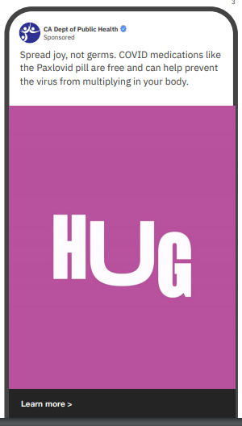elp prevent the virus from multiplying in your body.

**Caption**

Hugs are better when they’re healthy. If you test positive,

request COVID medication — free regardless of your insurance or citizenship status.

[Link to GIF](https://wdrv.it/35cf064d7)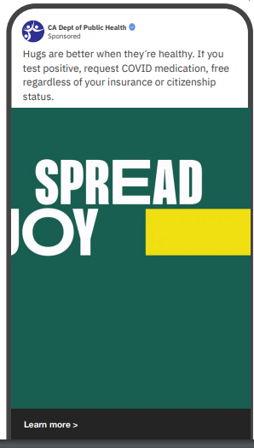

**Caption**

The biggest party foul? COVID. If you feel sick, test it and treat it.

Medication is free, safe and stops the virus from multiplying in your body.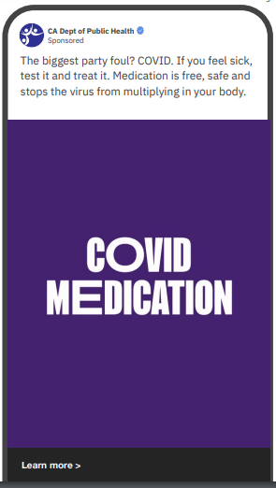

[Link to GIF](https://wdrv.it/c864c83cc)

**SPANISH LANGUAGE**

**ASSET #1 SOCIAL MEDIA CAROUSEL**

[**Link to assets Asset #1**](https://baru.box.com/s/i13vm01dhebtfrwlsfz6u3ibtfo5rwjy)

**CAPTION**

Los abrazos son mejores cuando son sanos. Si te sientes enfermo, hazte la prueba y pide las pastillas, son gratis y te pueden ayudar asalir negativo más rápido. No necesitas seguro. Llama hoy al (833) 422-4255.

BACK TRANSLATION —NOT TO BE USED ON CONSUMER FACING ADVERTISING  
Hugs are better when they are healthy. If you feel sick, get tested and ask for the pills, they are free and can help you test negative sooner. You don't need insurance. Call (833) 422-4255 today.

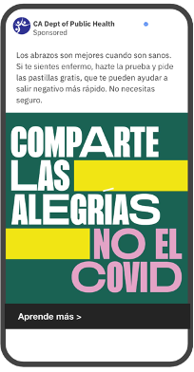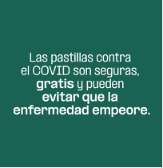

FRAME 2 FRAME 3

**ASSET #2 SOCIAL MEDIA CAROUSEL**

[**Link to assets Asset #2**](https://baru.box.com/s/9fu05iqgr2yvct7w66i2gl4b3zg5pzye)

**CAPTION**

Comparte alegrías, no COVID. Ya hay medicamentos gratis y seguros queayudan a evitar que el virus se multiplique en tu cuerpo. Si te sientesenfermo, hazte la prueba y pide las pastillas. Llama hoy al (833) 422-4255.

BACK TRANSLATI0ON —NOT TO BE USED ON CONSUMER FACING ADVERTISING  
Share joy, not COVID. There are already free and safe medications that helpprevent the virus from multiplying in your body. If you feel sick, get testedand ask for the pills. Call (833) 422-4255 today.

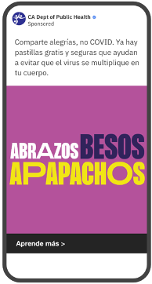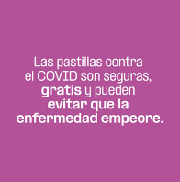  
  
 FRAME 2 FRAME 3   
  
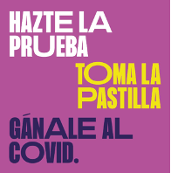

FRAME 4

**ASSET #3 SOCIAL MEDIA AD STATIC**

[**Link to assets Asset #3**](https://baru.box.com/s/7irhkxlv5swcj39kkwzsy31bg0c7wat9)

**CAPTION A**

Hazte la prueba. Toma la pastilla. Gánale al COVID. Ahora hay medicamentos gratis contra el COVID. No necesitas seguro. Llama hoy al (833) 422-4255.

BACK TRANSLATI0ON —NOT TO BE USED ON CONSUMER FACING ADVERTISING  
Take the test. Take the pill. Beat COVID. Now there are free medications against COVID. You don't need insurance. Call (833) 422-4255 today.

**CAPTION B**

Hazte la prueba. Toma la pastilla. Gánale al COVID. Si saliste positivo de COVID, pide los medicamentos gratis. Llama hoy al (833) 422-4255.

BACK TRANSLATI0ON —NOT TO BE USED ON CONSUMER FACING ADVERTISING  
Take the test. Take the pill. Beat COVID. If you tested positive for COVID, ask for the free medications. Call (833) 422-4255 today.

